HEALTH AI
Project Documentation
1.INTRODUCTION
• Team id: NM2025TMID08091
• Project title :HEALTH AI : INTELLIGENT HEALTHCARE ASSISTANT
•Team leader : S.INOOL SHAFIYA
• Team member : M.FATHIMA NASIFA
• Team member : R.LAKSHMI
• Team member : T.LAKSHMI
• Team member : R.KAMALA GOPIKA
2.PROJECT OVERVIEW
• Purpose :
The primary purpose of health AI projects is to revolutionize healthcare by improving diagnosis, treatment, and patient outcomes, while also increasing efficiency and reducing costs through automation and advanced data analysis. Key goals include enhancing diagnostic accuracy and speed, enabling personalized treatment plans, optimizing resource allocation, detecting and monitoring diseases, and improving administrative and operational efficiency by automating routine tasks
3.TYPES OF AI IN HEALTHCARE
AI is an umbrella term covering a variety of distinct but interrelated processes. Some of the most common forms of AI used within healthcare include the following:
- Machine learning (ML): Algorithms are trained using data sets, such as health records, to create models capable of performing tasks such as categorising information or predicting outcomes.
- Deep learning: This subset of machine learning involves greater volumes of data, training times, and layers of ML algorithms to produce neural networks capable of performing more complex tasks.
- Natural language processing (NLP): NLP involves using ML to understand human language, whether verbal or written. In healthcare, NLP is used to interpret documentation, notes, reports, and published research.
- Robotic process automation (RPA): This involves using AI in computer programs to automate administrative and clinical workflows. Some healthcare organisations use RPA to improve the patient experience and the daily function of their facilities

4. AI APPLICATIONS IN HEALTHCARE

- Healthcare analytics: ML algorithms are trained using historical data to produce insights, improve decision-making, and optimise health outcomes.
- Precision medicine: AI is used to produce personalised treatment plans for patients and consider factors such as their medical history, environmental factors, lifestyles, and genetic makeup.
• Predict diseases and illness: Using predictive models, healthcare professionals can determine the likelihood that someone might develop a particular condition or contract a disease.
• Interpret tests and diagnose diseases: ML models can be trained using common medical scans, like MRIs or X-rays, to interpret and diagnose conditions such as cancerous lesions.
5.FEATURES:
- As with many other industries, AI is poised to change the healthcare landscape over the coming years.
- In addition to improving health facility operations, patient diagnoses, treatment plan development, and overall health outcomes, AI is also expected to help develop and discover new medical cures.
- For instance, NITI Aayog, the public policy think tank of the Indian government, has been exploring the use of AI to detect diabetes early and is now focusing on employing AI as a screening tool in eye care.
- The use of AI in healthcare is expected to grow significantly over the next decade.
- According to Grand View Research, the global market for AI in healthcare is projected to expand at a CAGR of 38.5 percent between 2024 and 2030 .
- By 2025, India's investment in AI healthcare is forecasted to reach 11.78 billion USD, potentially resulting in a 1 trillion USD boost to the economy by 2035 .

6.AI JOBS IN HEALTHCARE
Both AI and healthcare are growing fields that are projected to have a big impact in the coming decade. It’s little surprise that AI-oriented positions are becoming increasingly common within healthcare.
If you’re interested in pursuing one of these careers, below are some of the positions you should consider exploring:

*Health informatics specialist
*Machine learning engineer
*Data scientist
*AI engineering

7.LIMITATION
- Disadvantages of AI in healthcare include high costs, potential for bias and misdiagnosis, significant data privacy and security risks, lack of the critical human touch, challenges with accountability and regulation, risk of over-reliance by healthcare professionals, and the potential for job displacement. Additionally, AI systems may not account for social variables, creating treatment disparities, and ensuring patient trust can be difficult.
8.NECESSARY IN HEALTHCARE
- Yes, AI is necessary in healthcare to improve diagnostic accuracy, personalize treatments, streamline administrative tasks, reduce costs, and enhance overall patient care and outcomes.
- By automating processes, analyzing vast datasets, and identifying patterns, AI assists healthcare professionals in making faster, more informed decisions, leading to more efficient resource allocation and a higher quality of care, ultimately making healthcare more accessible, effective, and sustainable.
9.ARCHITECTURE
1) A smart hospital is a digital interconnected healthcare ecosystem with quick and secure data exchange between medical devices and IT systems.
2) Smart hospitals can streamline clinical and administrative workflows, enhance operational efficiency, and improve patient experiences and healing processing.

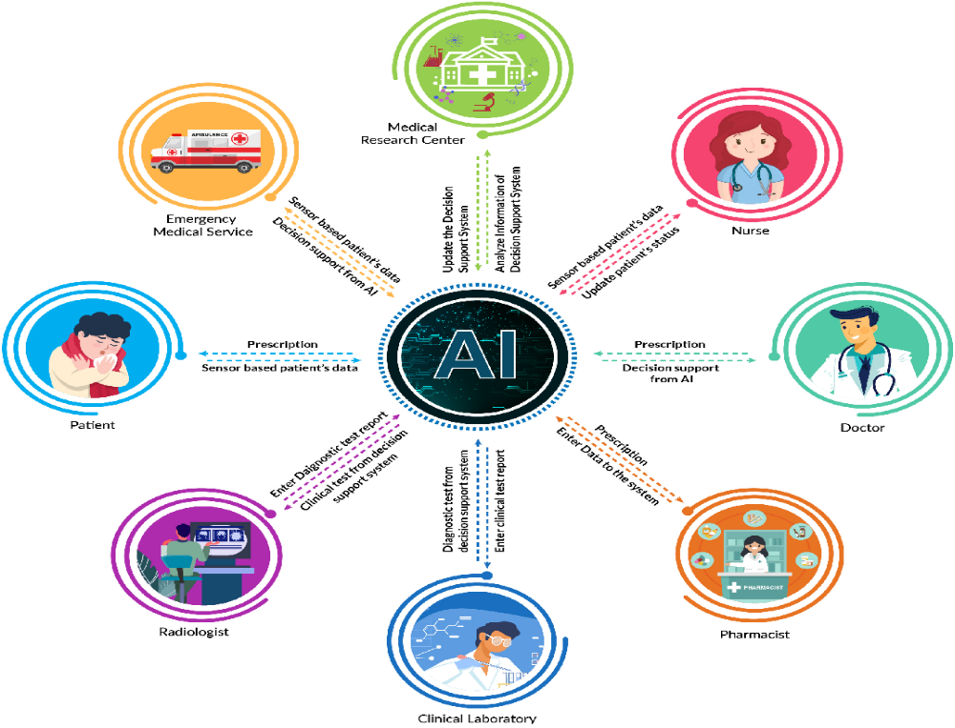

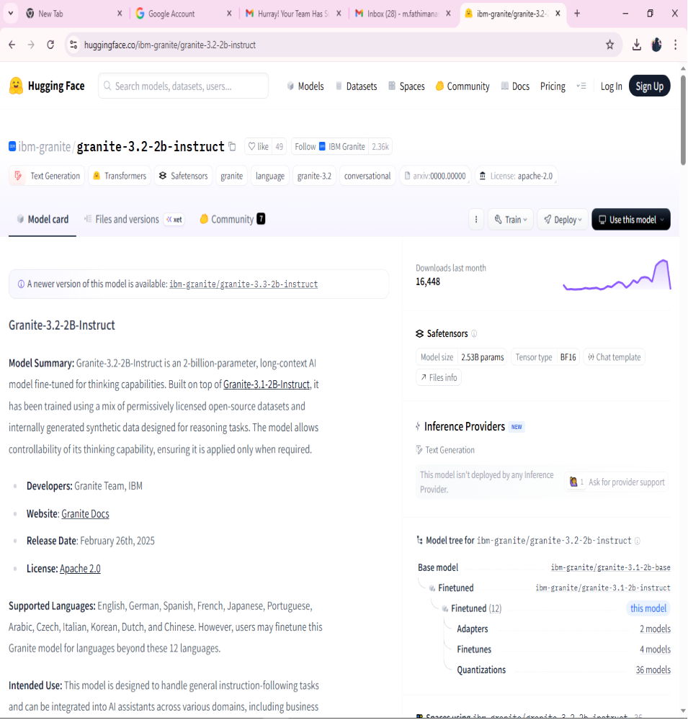
10.HUGGING FACE PAGE IS ON OPEN

11.GOOGLE COLAB PAGE IS ON OPEN
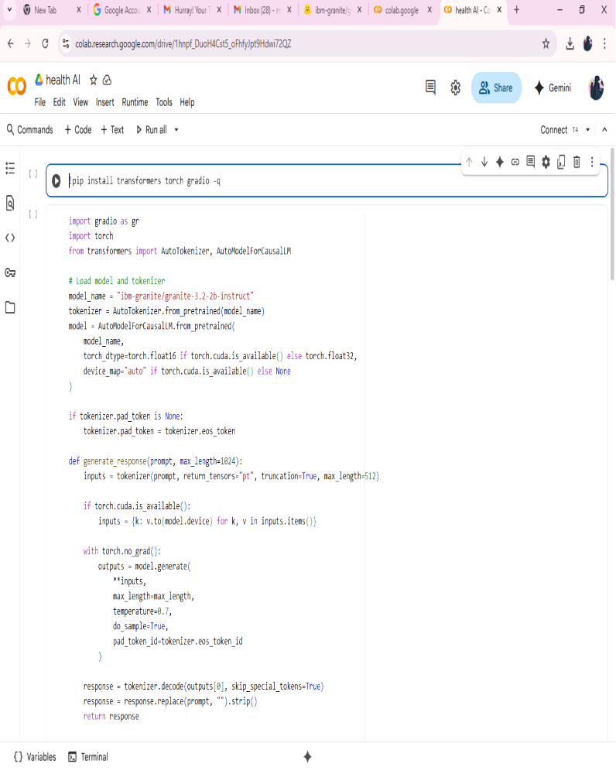

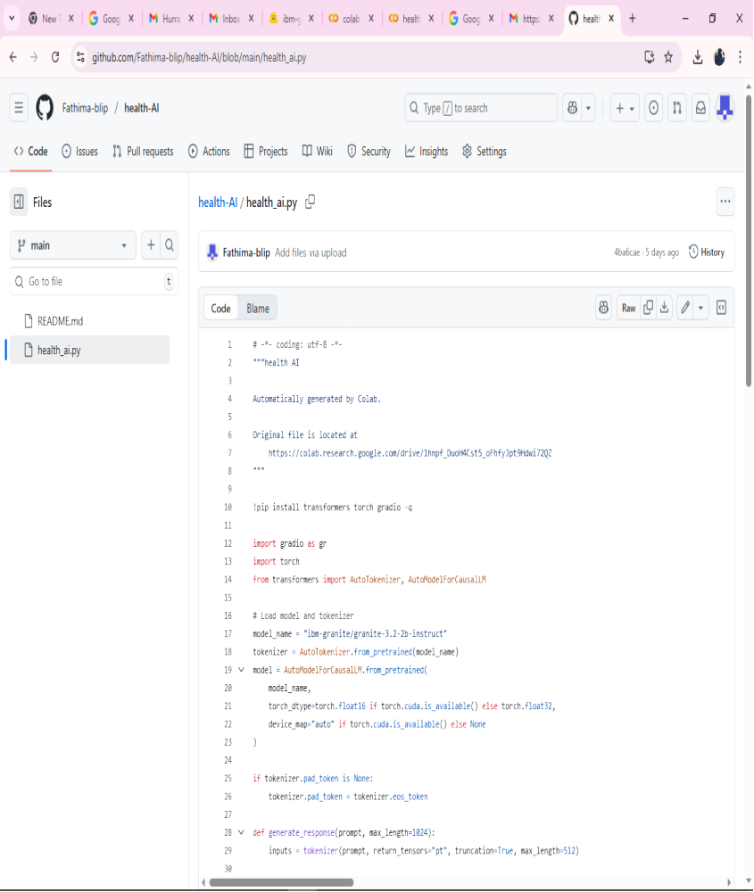
13.GITHUB PAGE IS ON OPEN

14.CONCLUSION
- The HealthAI project effectively demonstrates the potential of AI in revolutionizing healthcare assistance. By integrating IBM's Granite language model, the platform enables users to receive personalized health insights through Patient Chat, Disease Prediction, Treatment Plan Generation, and Health Analytics, making healthcare information more accessible.
- Utilizing IBM Watson Machine Learning, the application ensures accurate health question answering, detailed disease prediction, personalized treatment recommendations, and insightful health trend analysis. The structured development process—spanning model selection, core feature implementation, backend and frontend development, and deployment—led to the creation of an interactive, user-friendly platform.
- Built with Streamlit, HealthAI facilitates seamless visualization of health data and AI-generated insights, ensuring an efficient and responsive experience. This project highlights how targeted AI models and a well-structured framework can enhance healthcare accessibility. With future scalability in mind, HealthAI has the potential to expand its capabilities, incorporating more advanced diagnostics and broader medical applications.

